TABLE OF CONTENTS

I. Components 2

II. Objective 2

III. The Circuit 2

IV. Arduino Code 3

- COMPONENTS

The following components are used in the circuit.

1) | An Arduino UNO and its USB | 3) | A 5V DC Relay
 | cable | 4) | AC Power Supply
2) | A 220V AC Light Bulb | 5) | Connecting Wires

- OBJECTIVE

The aim is to turn on/off a 220V AC light bulb using a relay and an Arduino Uno microcontroller.

- THE CIRCUIT

Using Fritzing, a schematic diagram, figure 1, of the circuit was constructed.
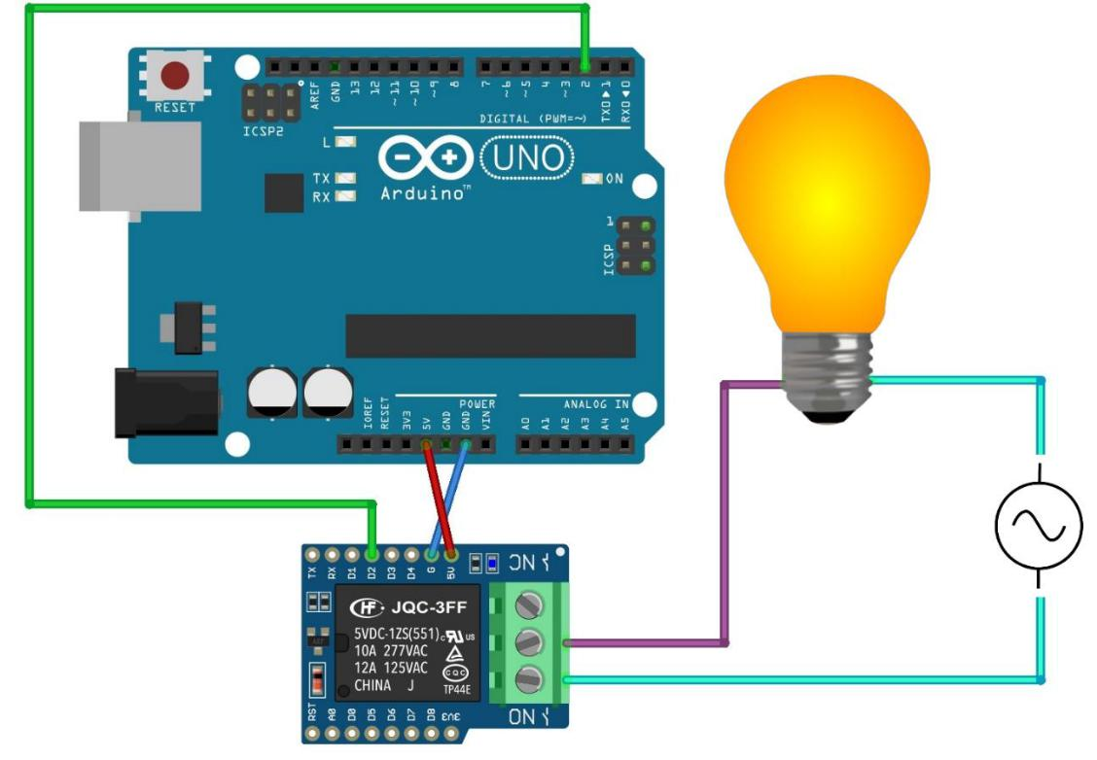

Figure 1 Schematic Representation of The Circuit

It is worthy to note that while testing the circuit in figure 1, the bulb would turn off when ordered to turn on and vice versa. Upon closer inspection, the problem turned out to be caused by the relay as it required a negative input voltage to energize the relay’s coil. Hence, connecting the bulb to the normally closed terminal, instead of to the normally open one, fixed this issue. However, the correct wiring should be as that of figure 1.

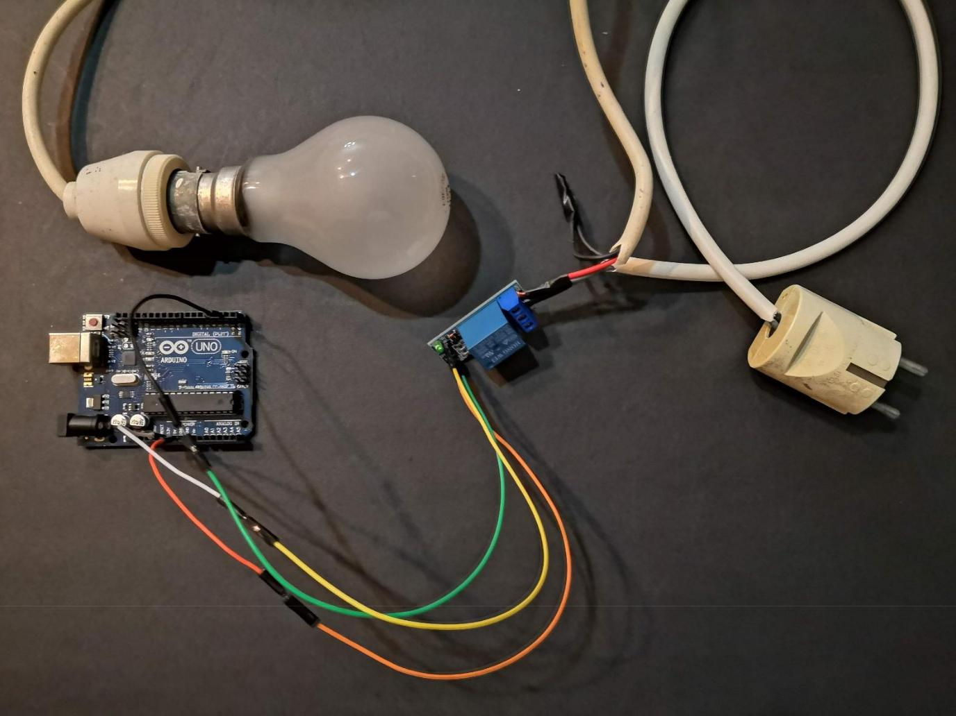

Figure 2 An Actual Picture of The Circuit

IV. ARDUINO CODE

int relay = 2;
int x;

void setup() {

pinMode(relay, OUTPUT);
Serial.begin(9600);

}

void loop() {

if (Serial.available() > 0) {

x = Serial.read();

switch (x) {
case ‘a’:
digitalWrite(relay, HIGH);
break;
case ‘b’:
digitalWrite(relay, LOW);
break;

}

}

}

